1.1 Concept of Machine Learning
1.1.1 Understanding Machine Learning:
What is Machine Learning?
Machine Learning (ML) is a field in computer science where computers learn from data and make decisions or predictions — without being directly programmed for every task. Instead of writing fixed instructions, we provide examples (called data) and let the machine find patterns on its own.
EXAMPLE: Think of a child learning to identify animals. First, we show the child pictures of cats and dogs. Then we tell the child, “This is a cat” or “This is a dog". After seeing many examples, the child starts identifying them correctly, even if it's a new picture.
Machine learning does the same!
We feed a lot of data (examples) into the computer. The computer studies the patterns and then makes predictions on new data.
Real Example:
• Email spam filter: Learns which emails are spam based on previous examples.
• Netflix suggestions: Learns your taste and suggestsshows.

1.1.2 Benefits of Machine Learning
Automation – Computers can do tasks without human help. Ex: Self-driving cars learn how to drive.
Faster and Smarter Decisions – It can make quick decisions from data. Ex: Credit card fraud detection.
Personalization – It givesresultssuited just for you.
Ex: YouTube recommends videos based on your interests.
Improves Over Time – The more data it gets, the better it becomes. Ex: Voice assistants like Alexa learn your voice over time.
Solves Complex Problems – Like medical diagnosis or language translation.

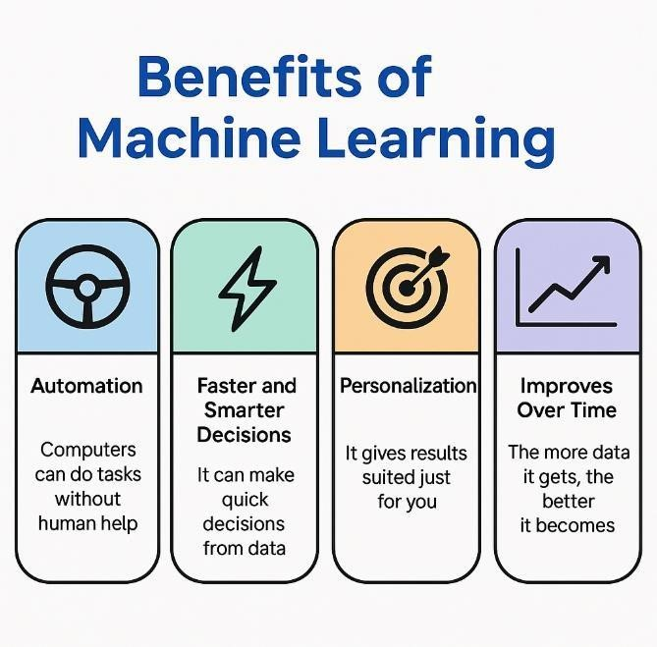

1.1.3 Difference between AI, ML, and Deep Learning

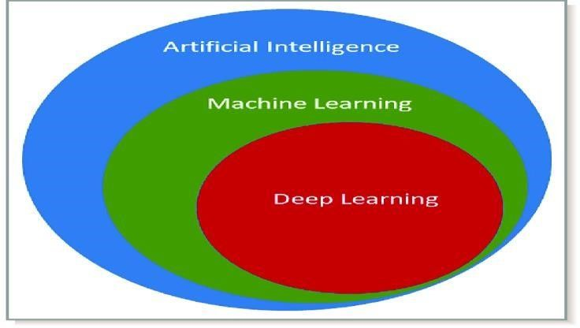

What is Artificial Intelligence (AI)?
- AI is the goal — It’s the final product: making a machine or system think and act smart like a human.
- AI is about giving intelligence to computers so they can solve problems, understand, learn, and respond — just like humans.
- AI includes everything from if-else rules, machine learning, robotics, language understanding, and more.

Analogy:
Think of AI as a self-driving car — that’s the smart final product.

What is Machine Learning (ML)?
ML is one of the main ways to reach AI.
ML focuses on structured data (neatly arranged data in tables: rows & columns).
In ML, we train the computer with data and let it find patterns so it can make decisions on its own.
Analogy: ML as a Student Learning from a Marks Sheet
Imagine a teacher giving a student a table (structured data) with the following columns:

Hours Studied Attendance (%) Assignment Score Final Exam Score
5 90 8 70
10 95 9 85
2 70 5 50

The student looks at many such rows and starts finding a pattern:
"If someone studies more, attends class regularly, and scores well in assignments, then their final exam score is likely to be higher." That student can now predict what a new student might score in the final exam based on similar values.

What This Means in ML:
The table is structured data (rows and columns).
The ML model learns patterns from this data.
Then it can predict or decide based on new input.
What is Deep Learning (DL)?

DL is a special part of ML that uses structures called neural networks — inspired by the human brain.
DL is used when the data is unstructured, like:
Images
Videos
Audio
Natural language (text,speech)

DL models need lots of data and powerful computers, but they can handle very complex tasks.
Analogy:
DL is like giving the self-driving car eyes and ears — so it can see roads (images), listen to commands (voice), and respond smartly without us giving it structured inputs.
Structured vs. Unstructured Data

Type of Learning Works Best With Examples
ML Structured Data (organized like Excel sheets or databases) Sales data, student scores
DL Unstructured Data (messy, natural formats) Photos, videos, emails, voice

Main difference:

Concept What it is Analogy
AI Final goal: Smart system A full smart kitchen that cooks on its own
ML A way to build AI using data A cooking assistant that learns your favorite recipesfrom structured steps
DL Advanced ML for unstructured data A robot chef that watches you cook and learns everything, even how you move and talk

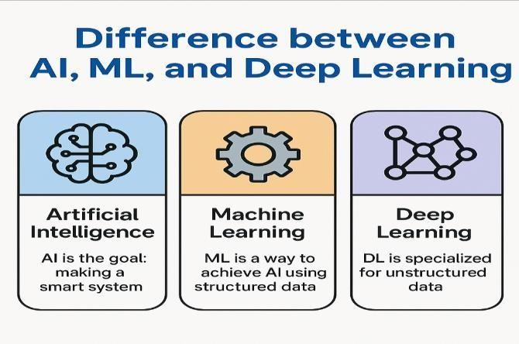

1.2 Machine learning Life Cycle
1.2.1 Stages of ML Life Cycle

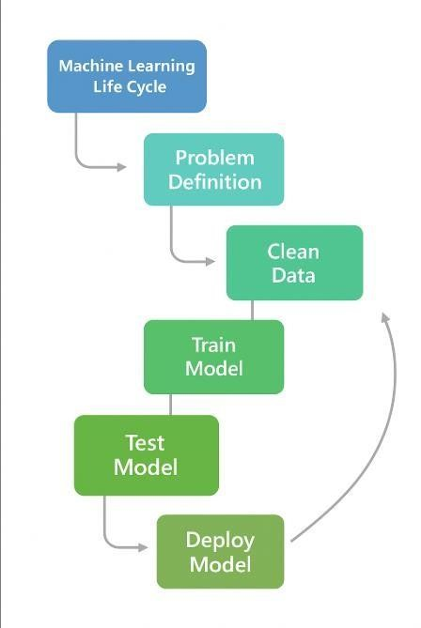

The Machine Learning (ML) Life Cycle refers to the step-by-step process of building, training, testing, and deploying an ML model to solve a real-world problem using data.

1. Problem Definition
What it means:
Define clearly what problem you are trying to solve with ML. Without a clear goal, the project will fail.
Examples:
• Predict the price of a house
• Identify whether an email is spam
• Recommend products to users
Analogy:
It’s like a student deciding which subject to study. The goal must be clearly understood before beginning the process.

2. Data Collection
What it means:
Gather the data that is relevant to the problem. This can be done using databases, APIs, surveys, or logs.
Examples:
• Customer demographics and purchase history
• Historical stock prices
• Patient health records
Analogy:
Just like a student collects books and notes to prepare for an exam, ML collects data as its learning material.

3. Data Cleaning / Preprocessing
What it means:
Raw data usually has missing values, errors, duplicates, or inconsistent formats. Cleaning it makes the data usable.
Tasks include:
• Removing null or duplicate entries
• Filling missing values with average or most frequent values
• Converting categorical data into numbers
Analogy:
Like organizing and rewriting messy notes before studying.
4. Feature Selection and Engineering
What it means:
Choose the most relevant variables (features) for the model and sometimes create new ones that help improve model performance.
Examples:
• Selecting “age” and “income” for a loan model
• Creating “total_marks” from multiple subject scores
Analogy:
Similar to summarizing your syllabus into key points so you can study better.
5. Model Training
What it means:
Feed the cleaned and prepared data into a chosen ML algorithm so it can learn from the patterns in the data.
Examples of algorithms:
• Linear Regression
• Decision Trees
• Support Vector Machines
Analogy: Just like a student study from solved papers and textbooks to prepare for the exam.

6. Model Testing / Evaluation
What it means:
Check how well the model performs using new data that it has never seen before.
Common evaluation metrics:
• Accuracy
• Precision and Recall
• Root Mean Square Error (RMSE)
Analogy: Like taking a practice test to evaluate how well you’ve studied.
7. Model Deployment
What it means:
Once the model performs well, it is deployed into a real-world environment so that users or systems can use it.
Examples:
• A chatbot answering customer queries
• A recommendation engine on an e-commerce site
Analogy: Like taking the final exam or presenting your project to a panel.

8. Monitoring and Maintenance
What it means:
Even after deployment, the model needs to be checked regularly. If it becomes less accurate due to changing data, it must be retrained or updated.
Examples:
• Updating the model with new customer data
• Fixing bugs or improving performance
Analogy: Like continuing to revise or practice a subject after the exam is over to stay up to date.

1.2.2 Problem Definition to Model Monitoring

Stage | Description | Analogy
Problem Definition | Define what to solve | Choose your subject to study
Data Collection | Gather related data | Collect books and notes
Data Cleaning | Fix and format the data | Clean and organize your notes
Feature Engineering | Choose or create useful features | Summarize key study topics
Model Training | Teach the model using data | Study from books and examples
Model Testing | Evaluate with new data | Take a practice test
Model Deployment | Put the model into real use | Present the final answer or appear in exam
Monitoring | Keep checking and updating the model | Continue practicing and revising

